**Fix for kibana server not ready yet**

Change the following in the /etc/elasticsearch/elasticsearch.yml 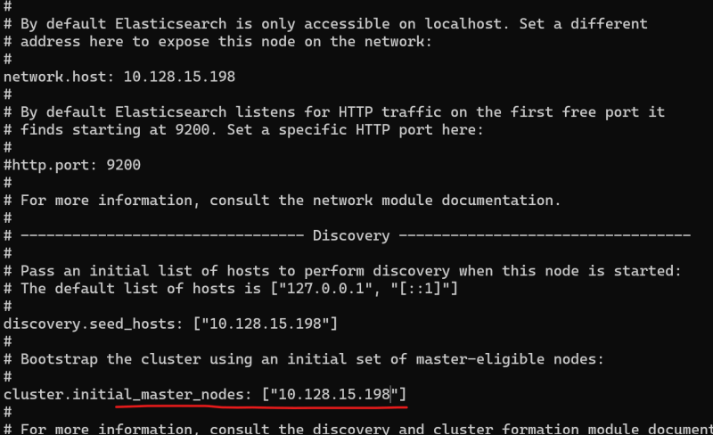

Note: add the private ip of your elastic search server in the above highlighted section and restart elastic search and kibana 

**Elastic Search**

* Elastic search plays the central role of search and analytics engine
* Elastic search is built on Apache Lucene.
* Benifits of Elastic Search
  + Schemaless and document oriented:
    - Elastic search doesn’t impose a strict structure on your & you can store any json documents
    - Example documents

{

"name": "Ram",

"address": " Near mythrivanam, Hyderabad",

"courses": ["DevOps"]

}

{

"name": "Robert",

"email": "robertatqt@gmail.com"

}

* + Searching Capability:
    - The core strength of Elastic search lies in its text searching capabilities. This also implements Full text search
  + Analytics:
    - Elastic search supports a wide variety of aggregations for analytics. These aggregations are quite powerfull and can be applied for various data types
  + Rich Client library support and the REST API
    - Elastic search has very rich client library support to make it accesible to many programming languages (Java, C#, Python, JavaScript, PHP, Ruby)
    - Elastic search has a Very RICH REST API (Which works on http)
  + Easy to operate and Easy to scale:
    - Elastic search can run on single node and easily scale to hundreds of nodes
  + Lightning Fast
  + Fault-tolerant

**Setting up Kibana**



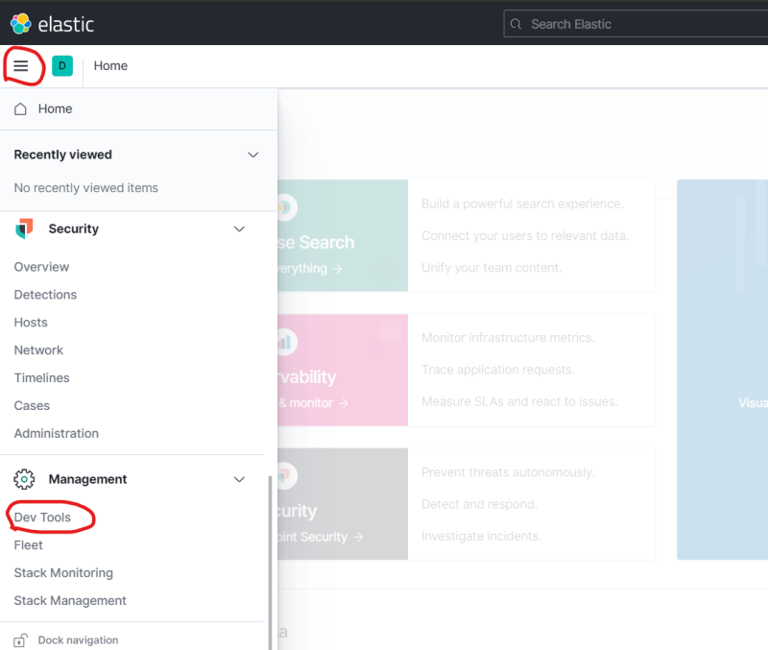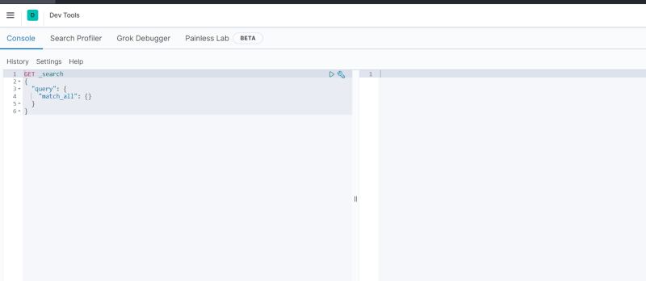

**Core Concepts of Elastic Search**

* Following are the core concepts of Elastic Search
  + Indexes
  + Types
  + Documents
  + Clusters
  + Nodes
  + Shards & replicas
  + Mappings & Types
  + Inverted Indexes
* Example: Add the following using Kibana console

PUT /library/_doc/1

{

"title": "Mind Hacking, Unfck Yourself, Rich Dad Poor Dad, Smarter Faster Better 4 Books Collection Set",

"ISBN-10": "1612680178",

"Authors": [

"Sir John Hargrave", "Gary John Bishop", "Charles Duhigg", "Robert T. Kiyosaki"

],

"Edition": 2,

"Binding": "Paperback",

"List Price": "0.17$",

"Published": "January 2020"

}

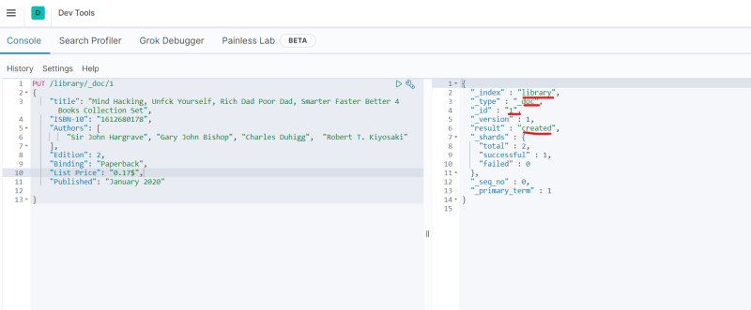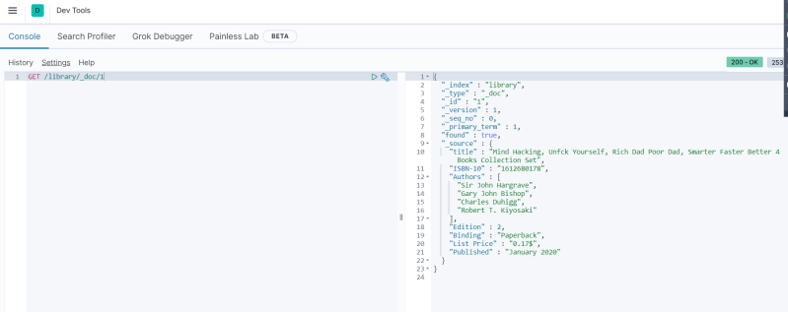

Elastic search can also be interacted using curl 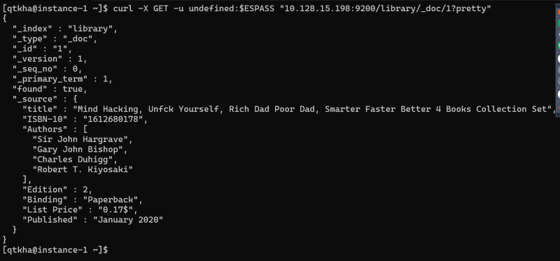

**Indexes**

* An *index* is a container that stores and manages documents of single type in elastic search 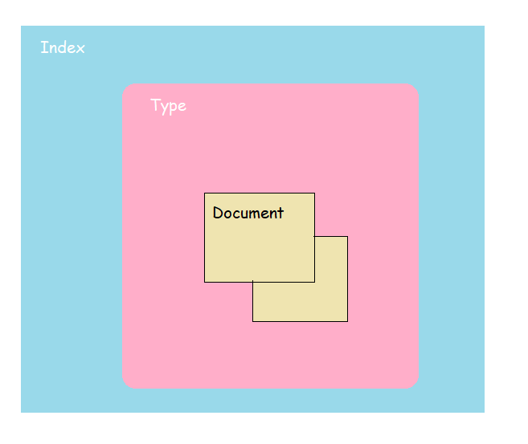
* The concept of index in Elastic search is roughly analogues to the database schema in relational database. Going by this analogy, a type in Elasticsearch is equivalent to table and document is equivalent to record in the table.

**Types**

* In our example of library, the document that was indexed was of library type. Each document stored in the library type represent one book
* Typically documents with mostly common set of fields are grouped under one type

PUT /library/_doc/1

{

"title": "Mind Hacking, Unfck Yourself, Rich Dad Poor Dad, Smarter Faster Better 4 Books Collection Set",

"ISBN-10": "1612680178",

"Authors": [

"Sir John Hargrave", "Gary John Bishop", "Charles Duhigg", "Robert T. Kiyosaki"

],

"Edition": 2,

"Binding": "Paperback",

"List Price": "0.17$",

"Published": "January 2020"

}

PUT /library/_doc/2

{

"title": "Who Moved My Cheese",

"ISBN-13": "9780399144462",